# TABLE OF CONTENTS

TABLE OF CONTENTS 1

LINUX 2

Linux distributions 2

General features of Linux 3

Basic commands 3

Working with files 4

The BASH shell 5

Directory structure 5

INSTALLATION OF CENTOS 6.3 AND FEDORA 18/19 6

CENTOS 6.3 6

FEDORA 18 21

Warnings 29

SERVERS 29

How to create servers on a PC 31

Setting up DNS (BIND) 31

Setting up Mail Server. 36

Setting up the file 42

Setting up a Apache Web server 47

Setting up database server (Postgresql) 49

# LINUX

Linux is an open source operating system. Open source refers to a family of software licenses where the source code is available to the public with little or no copyright restrictions.

Linux just like any other OS performs mainly the following roles:

* Manages the computer hardware resources
* Provides a platform for running applications on desktops, servers, clusters.

Linux is the kernel i.e. the program in the system that allocates the machines resources to the other programs that are running in that machine. Normally is used in combination with the GNU operating system.

First version was released in 1991 by Linus Torvalds.

## Linux distributions

There are many distributions of Linux, some of them include;

* Ubuntu
* Linux mint
* Fedora
* Debian
* OpenSUSE
* Archlinux
* Puppy
* CentOS
* Sabayon
* Mandriva
* Slackware
* Knoppix
* Gentoo linux
* Scientific
* Red hat
* Deepin
* Vinux
* SMS
* Vector
* Edubuntu
* Lubuntu
* Kali

Each one of the above distributions offers a unique combination of features and applications to suit needs of different users.

## General features of Linux

* Most distributions are free
* Open-source (completely customizable)
* Portable to nearly any hardware platform
* Highly scalable to lots of cores, or lots of memory
* Highly efficient, therefore useful for computation
* Robust and proven security model
* Includes a complete development environment

Command line interface is the most common way to access and use Linux thus it is important that we know how to compute from the command line.

Basic commands;

* awk allows manipulation of text
* bg place suspended job into background
* cat view contents of a file
* cd change directory
* chmod change permissions on a file/directory
* cp copy a file
* cut extract a field of data from text output
* echo output text to the terminal or to a file
* emacs text editor
* fg bring suspended job to foreground
* file display file type
* find search for files
* grep search a file or command output for a pattern
* head view beginning of file
* history display list of most recent commands
* less scroll forward or back through a file
* ln create a link to a file
* ls list files in a directory
* man view information about a command
* mkdir make directory
* more scroll through file a page at a time
* mv change the name of a file (move)
* nano/pico text editors
* printenv display shell variables
* ps show current process information
* pwd print current working directory
* rm delete or remove a file
* rmdir delete or remove a directory
* sed stream editor
* sleep pause
* sort perform a sort of text
* stat display file status info
* tail view end of the file
* touch create an empty file or update timestamps
* tr character substitution tool
* uniq remove identical, adjacent lines
* vi/vim text editor
* wc print number of lines, words or characters
* which shows full path of a command
* whoami displays username

Working with files;

* cp [file1] [file2] – create a copy of a file
* mv [file] [destination] – move (or rename) a file
* rm [file] – delete a file (rm -r [dir] for a folder)
* file [file] – print the type of file
* more [file] – read a text file, one “page” at a time
* less [file] – similar to more, but a little better
* head -n [file] – print the first n lines of a file
* tail -n [file] – print the last n lines of a file
* cat [file] – print the contents of a file to the screen
* grep error [file] - searches a file for lines containing “error” and prints them to stdout
* tar -cvzf [compressed_archive].tar.gz [directory] – zips a directory into a single compressed file,
* scp [file] usename@server:path_to_destination - useful for file transfers
* scp -r [dir] usename@server:path_to_destination - useful for directory or folder transfers.
* scp => Secure Copy. Used to copy a file or folder or directory to another computer where you have a user account.

Also,

* scp usename@server:path_to_remote_file path_to_destination_file
* scp -r usename@server:path_to_remote_dir path_to_destination_dir

Just to make your learning of a specific Linux distribution easier, you will find that almost all commands have an accompanying manual page, so type man and then the command. For example; man cp, man ls, man man.

To exit the manual page viewer simply type the letter Q.

While in the command line, you can view the entire history of commands you have used by typing ‘history’ in the command line. For instance, to view the last 10 commands type

‘history 10’ without the quotes.

## The BASH shell

Also known as Bourne-again shell. It is a command line interpreter and allows users to type commands that cause actions.

File and Directory Permissions;

Control access to files & directories by setting permissions

* cd intro.linux
* ls –l
* -rwxr-xr-x 1 jebalunode public 622783 2010-12-03 09:15 dictionary.txt
* -rwxr-xr-x 1 jebalunode public 8262 2010-12-03 09:15 icb.txt
* -rwxr-xr-x 1 jebalunode public 891777 2010-12-03 09:15 personnel.txt
* -rwxr-xr-x 1 jebalunode public 6599 2010-12-03 09:15 theraven.txt
* Setting permissions using read /write or executable :
* chmod +r [file] --makes a file readable
* chmod +w [file] –writes to the file are permitted
* chmod +x [file] --makes a file executable
* chmod +rwx [file] --makes a file executable, writable and readable
* For directorys you apply the recursive “R”
* chmod -R +r [dir] --makes a directory readable.

## Directory structure

* / root
* /bin bare essential commands
* /boot OS Kernels
* /dev hardware devices
* /etc system files, configuration
* /home home directories
* /lib Libraries needed by the system
* /opt 3rd party applications
* /proc Running processes
* /sbin administrative commands
* /tmp temporary space
* /usr operating system applications
* /var Logs, databases and other variable length stuff

This is just a summarized introduction, if you are interested in using Linux then try to practice these commands and look for more resources.

# INSTALLATION OF CENTOS 6.3 AND FEDORA 18/19

Among the many versions of Linux such as Kali Linux, Ubuntu, Mint, openSUSE, SELinux, CentOS and Fedora are among them. Just like any other Linux operating system, they are open source and mainly operated from the terminal or the console.

CentOS and Fedora have a lot in common compared to their differences

## CENTOS 6.3

**Boot Computer with CentOS 6.3 OS Installation CD/DVD.**

1. Select **Install** or **Upgrade** existing system options.

[[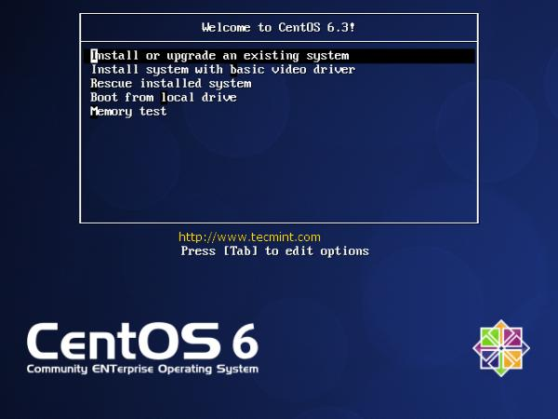](http://www.tecmint.com/wp-content/uploads/2012/07/cent-1.jpg)](http://www.tecmint.com/wp-content/uploads/2012/07/cent-1.jpg)Select Install or Upgrade

2. Choose **skip** media test as it may take long time to check media.

[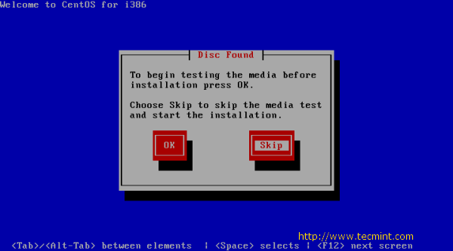](http://www.tecmint.com/wp-content/uploads/2012/07/cent-2.png)Skip CentOS 6.3 Media Test

3. CentOS 6.3 Welcome Screen press **Next**.

[[](http://www.tecmint.com/wp-content/uploads/2012/07/cent-3.png)](http://www.tecmint.com/wp-content/uploads/2012/07/cent-3.png)CentOS 6.3 Welcome Screen

4. **Language** Selection.

[[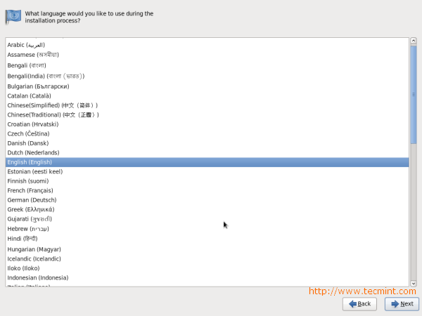](http://www.tecmint.com/wp-content/uploads/2012/07/cent-4.png)](http://www.tecmint.com/wp-content/uploads/2012/07/cent-4.png)CentOS 6.3 Language Selection

5. Select appropriate **Keyboard**.

[[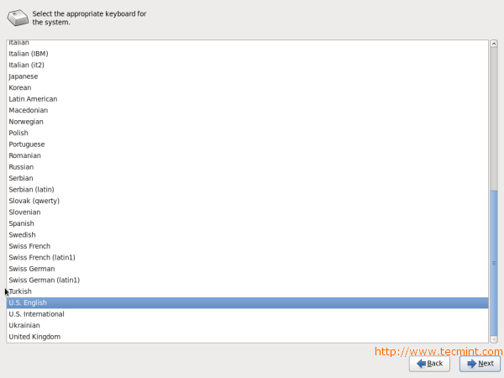](http://www.tecmint.com/wp-content/uploads/2012/07/cent-5.png)](http://www.tecmint.com/wp-content/uploads/2012/07/cent-5.png)CentOS 6.3 Keyboard Selection

6. Select **Basic Storage Device** if your hard drive is attached locally.

[[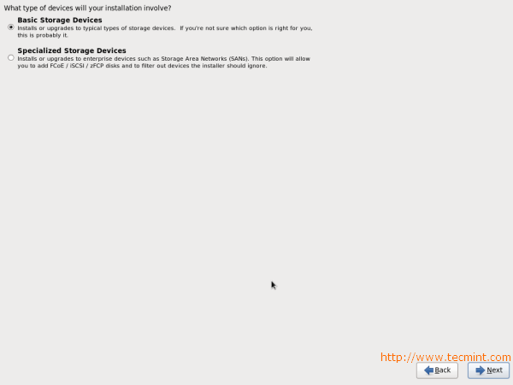](http://www.tecmint.com/wp-content/uploads/2012/07/cent-6.png)](http://www.tecmint.com/wp-content/uploads/2012/07/cent-6.png)CentOS 6.3 Storage Device Selection

7. You may get **Storage Device** warning, you can click **Yes**, discard any data button to **Continue**.

[[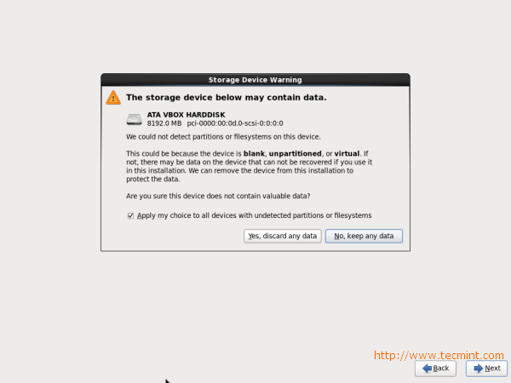](http://www.tecmint.com/wp-content/uploads/2012/07/cent-7.png)](http://www.tecmint.com/wp-content/uploads/2012/07/cent-7.png)CentOS 6.3 Storage Device Warning

8. Give a **Hostname** to the server and click on **Configure Network** button if you want to configure network while installation.

[[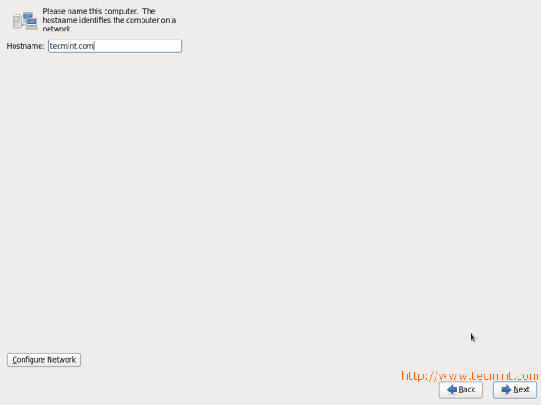](http://www.tecmint.com/wp-content/uploads/2012/07/cent-8.png)](http://www.tecmint.com/wp-content/uploads/2012/07/cent-8.png)CentOS 6.3 Hostname and Network Setup

9. Click **Wired** tab and click on **Add** button.

[[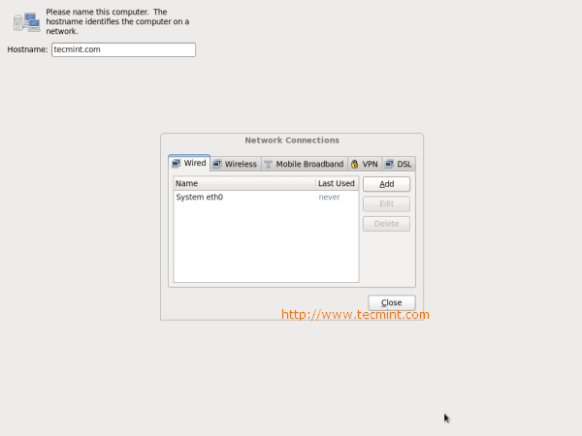](http://www.tecmint.com/wp-content/uploads/2012/07/cent-9.png)](http://www.tecmint.com/wp-content/uploads/2012/07/cent-9.png)CentOS 6.3 Network Setup

10. Select **Connect Automatically**, go to **ipv4 settings** tab and select **Method** and select **Manual** in drop down. Click on **Add** tab to fill address box with **IP Address**, **Netmask**, **Gateway** and **DNS Server**. Here I’m using IP Address **192.168.1.6** and DNS Server is **4.2.2.2** for demo. This IP Address may vary in your environment.

[[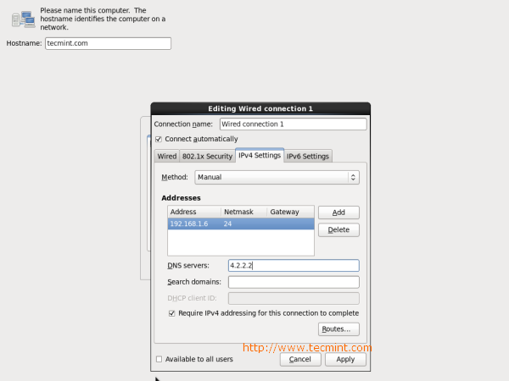](http://www.tecmint.com/wp-content/uploads/2012/07/cent-10.png)](http://www.tecmint.com/wp-content/uploads/2012/07/cent-10.png)CentOS 6.3 Network Configuration

11. Select **Time Zone**.

[[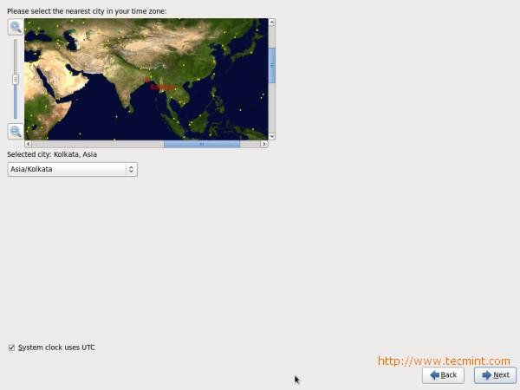](http://www.tecmint.com/wp-content/uploads/2012/07/cent-11.jpg)](http://www.tecmint.com/wp-content/uploads/2012/07/cent-11.jpg)CentOS 6.3 Set Timezone

12. Give a **root password**.

[[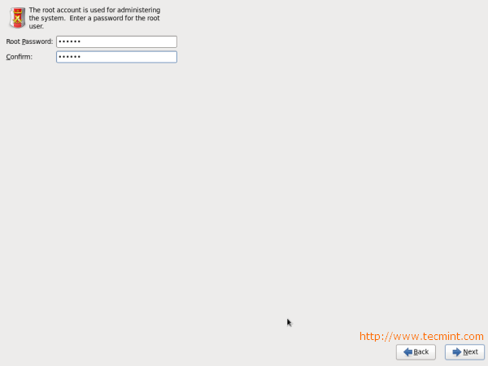](http://www.tecmint.com/wp-content/uploads/2012/07/cent-12.png)](http://www.tecmint.com/wp-content/uploads/2012/07/cent-12.png)CentOS 6.3 root Password

13. Select appropriate partitioning as per your requirement.

[[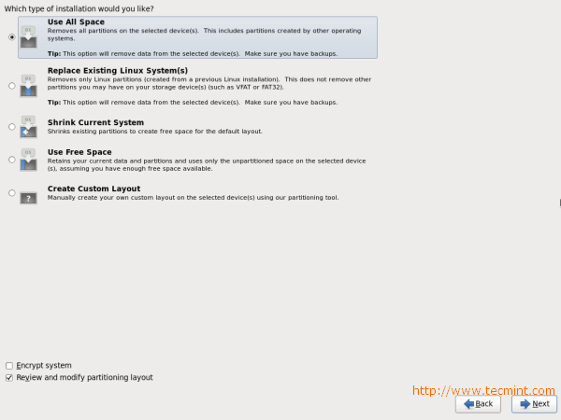](http://www.tecmint.com/wp-content/uploads/2012/07/cent-13.png)](http://www.tecmint.com/wp-content/uploads/2012/07/cent-13.png)CentOS 6.3 Partition Selection

14. Verify filesystem. Here, you can edit filesystem If you want.

[[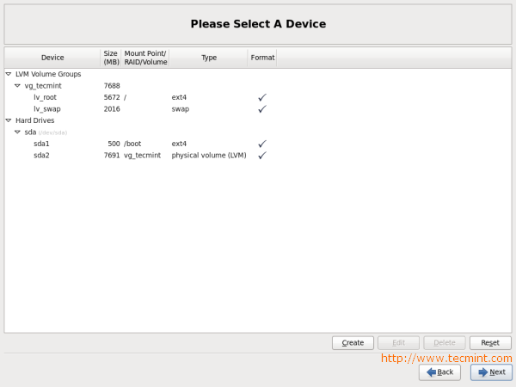](http://www.tecmint.com/wp-content/uploads/2012/07/cent-14.png)](http://www.tecmint.com/wp-content/uploads/2012/07/cent-14.png)CentOS 6.3 Partition Verify

15. Disk **Format Warning**, click on Format.

[[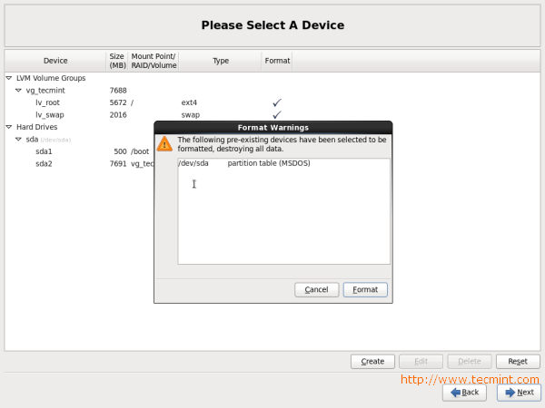](http://www.tecmint.com/wp-content/uploads/2012/07/cent-15.png)](http://www.tecmint.com/wp-content/uploads/2012/07/cent-15.png)

CentOS 6.3 Disk Format

16. Select **Write Changes** to disk.

[[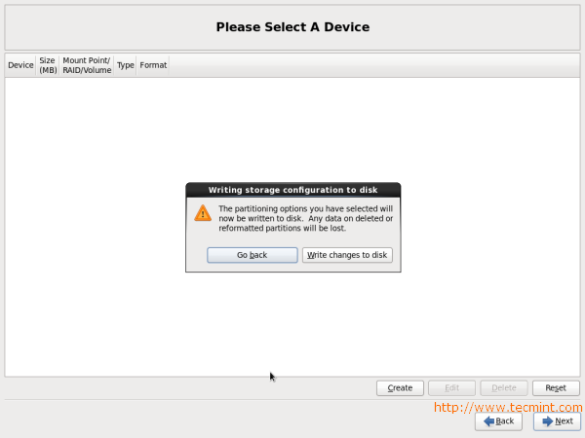](http://www.tecmint.com/wp-content/uploads/2012/07/cent-16.png)](http://www.tecmint.com/wp-content/uploads/2012/07/cent-16.png)CentOS 6.3 Disk Changes

17. Hard Drive is **Formatting**.

[[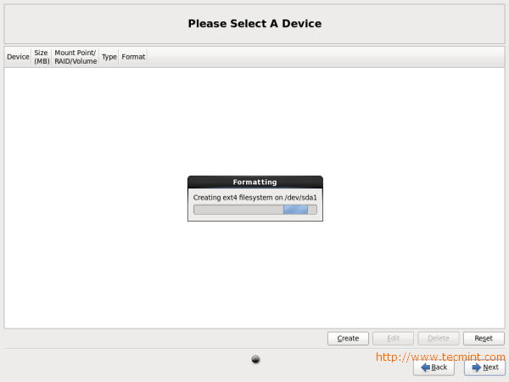](http://www.tecmint.com/wp-content/uploads/2012/07/cent-17.png)](http://www.tecmint.com/wp-content/uploads/2012/07/cent-17.png)CentOS 6.3 Disk Formatting

18. Here, you can give **Boot loader Password** for better security.

[[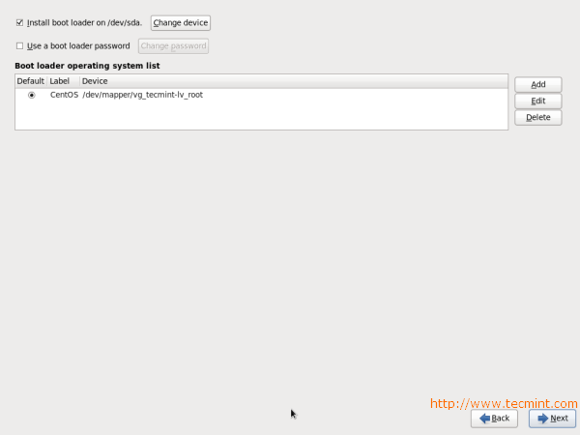](http://www.tecmint.com/wp-content/uploads/2012/07/cent-18.png)](http://www.tecmint.com/wp-content/uploads/2012/07/cent-18.png)CentOS 6.3 Boot Loader Password

19. Select the applications you want to install, you can choose **Customize now** and click **Next**.

[[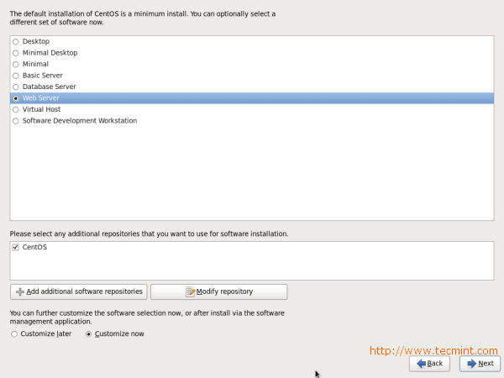](http://www.tecmint.com/wp-content/uploads/2012/07/cent-19.png)](http://www.tecmint.com/wp-content/uploads/2012/07/cent-19.png)CentOS 6.3 Package Selection

20. Select the applications you want to install and click **Next**.

[[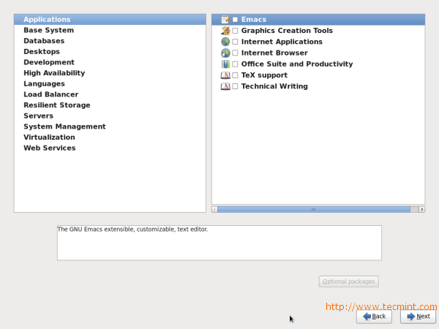](http://www.tecmint.com/wp-content/uploads/2012/07/cent-20.png)](http://www.tecmint.com/wp-content/uploads/2012/07/cent-20.png)CentOS 6.3 Packages Selection

21. Installation started, this may take several minutes as per selection of packages.

[[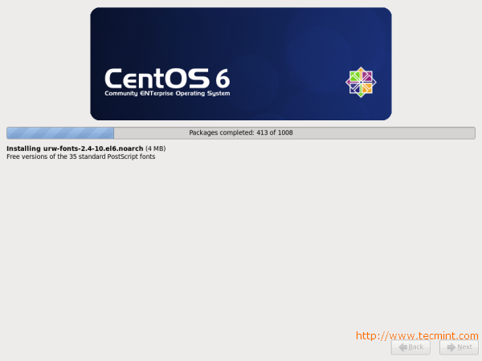](http://www.tecmint.com/wp-content/uploads/2012/07/cent-21.png)](http://www.tecmint.com/wp-content/uploads/2012/07/cent-21.png)CentOS 6.3 Installation

22. Installation completed, Please remove **CD/DVD** and **reboot system.**

[[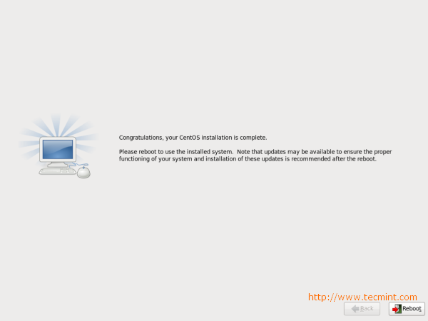](http://www.tecmint.com/wp-content/uploads/2012/07/cent-22.png)](http://www.tecmint.com/wp-content/uploads/2012/07/cent-22.png)CentOS 6.3 Installation Completes

23. Welcome to CentOS 6.3 **Login Screen**.

[[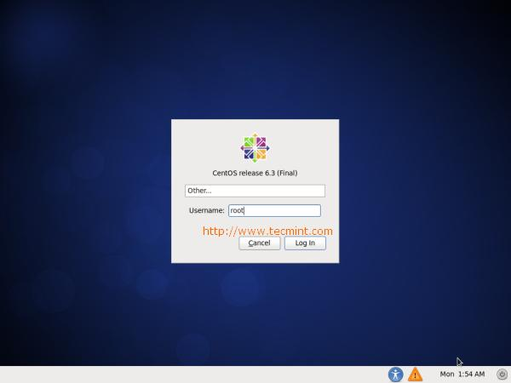](http://www.tecmint.com/wp-content/uploads/2012/07/cent-23.jpg)](http://www.tecmint.com/wp-content/uploads/2012/07/cent-23.jpg)CentOS 6.3 Login Screen

24. CentOS 6.3 **Desktop Screen.**

[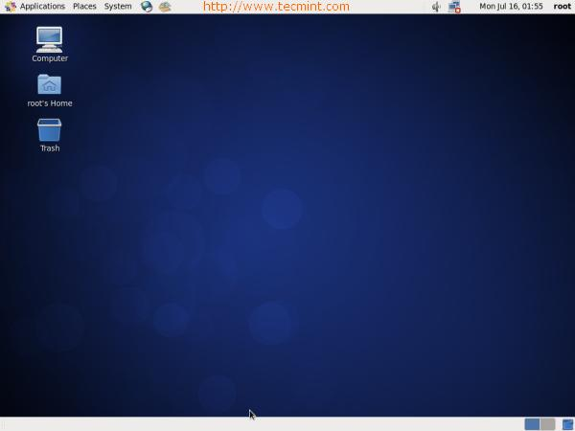](http://www.tecmint.com/wp-content/uploads/2012/07/cent-24.jpg)

## FEDORA 18

Fedora is another version of Linux operating system. This set of instructions shows how to install Fedora operating-system on your system, provided that you have a Fedora live CD or USB.

**Download the live image from the** [**fedoraproject**](http://fedoraproject.org/get-fedora) **website.** Burn the .iso to a CD, DVD or a USB stick. Make sure that you write it at a slow speed so that nothing gets broken in the process.

[**Change the BIOS settings.**](http://www.wikihow.com/Change-Computer-BIOS-Settings) If you are using a live USB, you might need to go into your BIOS and change the boot priority in order to boot from your USB. You can access your computer's BIOS by pressing ‘F2’ or ‘Delete’ on most computers when the computer is booting up. If you are using a CD or DVD, ignore this step as generally CDs are first in boot priority.

**Be sure to select "Live Drive" when the option screen first appears.** If you select to install it, it can potentially delete everything from your system.

**Explore the system.** The most notable thing about you should toy with is the window manager which allows you to see pretty cool effects. You should also explore around the applications already installed in the OS and see what else is available with their package manager.

**Install the live image to your hard drive .**If you have made the decision to install Linux on your system, click on the "Install to Hard drive" icon on the workspace.

[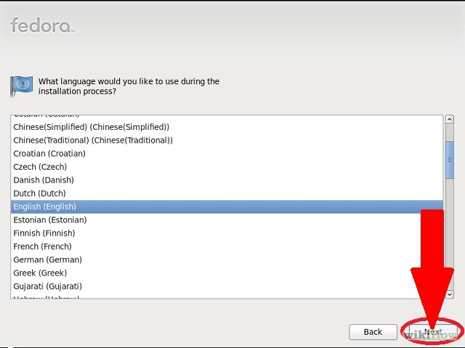](http://www.wikihow.com/Image:Install-Fedora-Step-7.jpg)

**Click on next when the installer starts and then select your keyboard layout.**

[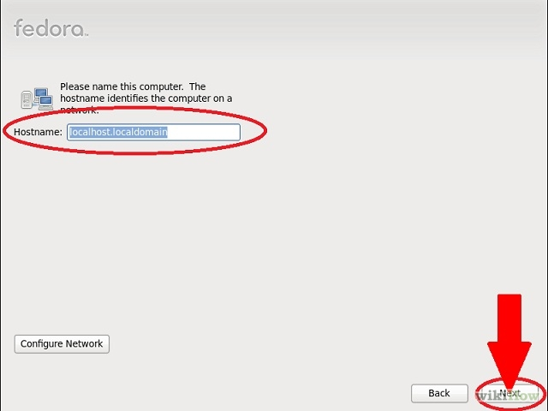](http://www.wikihow.com/Image:Install-Fedora-Step-8.jpg)

**Choose the host name.** It can be left as is or you can enter in the name you desire. That is going to be the name for the computer. Then click on next.

[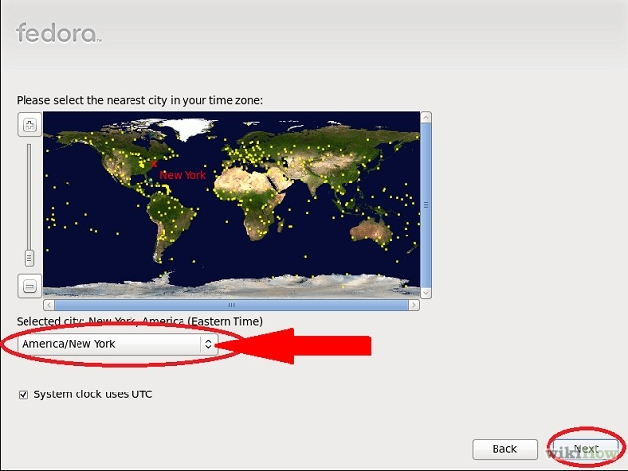](http://www.wikihow.com/Image:Install-Fedora-Step-9.jpg)

**Select your** [**time zone**](http://www.wikihow.com/Tell-Time-Without-a-Clock) **and click next.**

[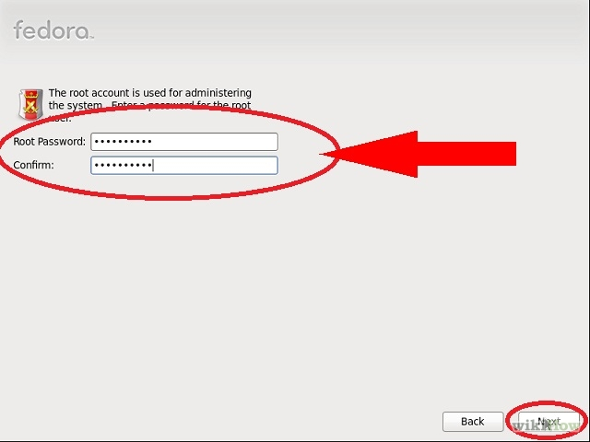](http://www.wikihow.com/Image:Install-Fedora-Step-10.jpg)

**Enter your root password for the system.** Make sure that the password is something hard for others to guess; the security of your system depends on it.

[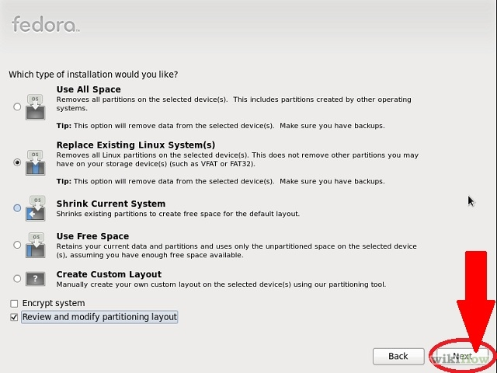](http://www.wikihow.com/Image:Install-Fedora-Step-11.jpg)

**Choose the mode of installation.** You could:

* + Use entire drive. As the title says, Fedora would clear off all the data on your hard drive and use the complete space for its installation. But beware that you could lose all data on your drive.
  + Use free space. If you have unallocated space on your hard drive, all that space is used for Fedora installation.
  + Replace existing Linux System. If you are sure that you are running another Linux distribution and are quite keen to remove it, use this option and click next.
  + Shrink current system. This option allows you to shrink any of the partitions so as to install Fedora.
  + Create Custom Layout. Allows you to create and delete partitions manually. (Experienced users only.)

[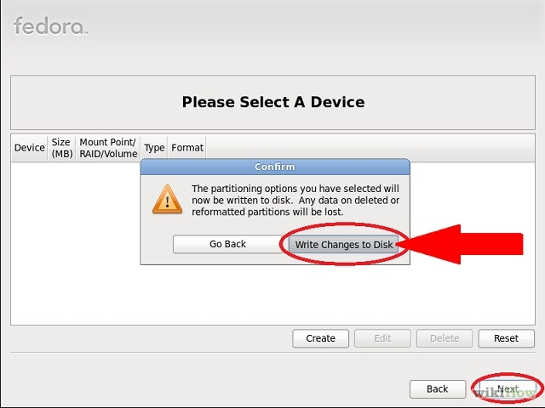](http://www.wikihow.com/Image:Install-Fedora-Step-12.jpg)

**Choose one which suits you the most and click next.** Confirm by clicking on ‘write changes to disk’.

[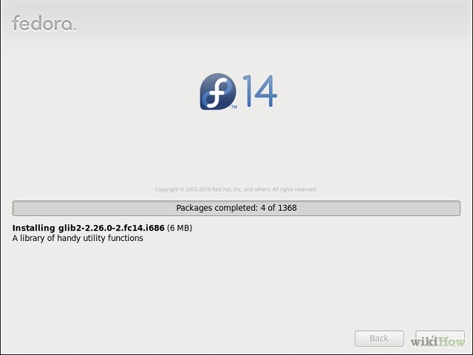](http://www.wikihow.com/Image:Install-Fedora-Step-13.jpg)

**Till the install process finishes, wait for it to complete the install.** After this installation starts, it will take approximately take 5-10 minutes (depending on your system) for it to be complete.

[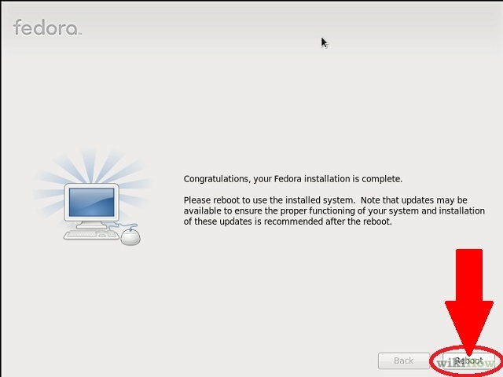](http://www.wikihow.com/Image:Install-Fedora-Step-14.jpg)

**Re-boot the computer when the installation is done.** Go to System > Shut Down and make sure to remove your live CD from the CD drive or your USB drive from the USB port.

[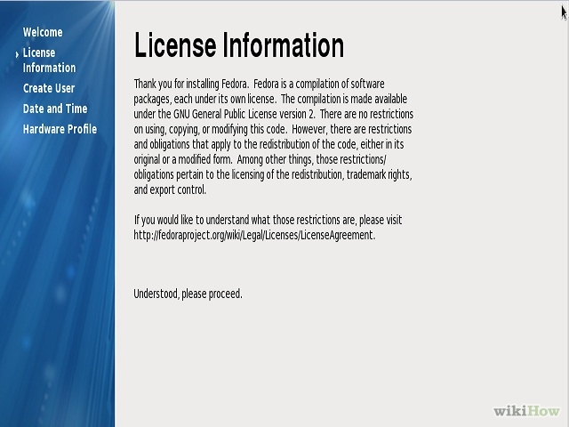](http://www.wikihow.com/Image:Install-Fedora-Step-15.jpg)

**Click on ‘forward’ on the first boot wizard and read and accept the license agreement.**

[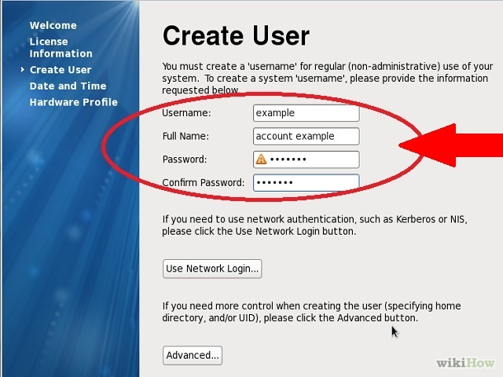](http://www.wikihow.com/Image:Install-Fedora-Step-16.jpg)

**Click on forward again.** At the Create User prompt, enter the user name you desire, your full name, and your password.

[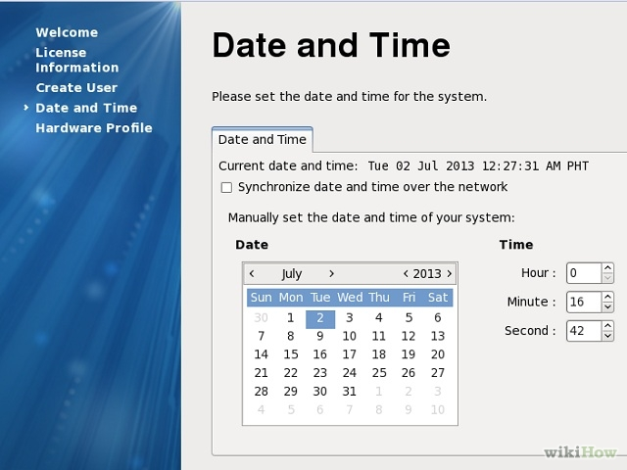](http://www.wikihow.com/Image:Install-Fedora-Step-17.jpg)

**Set your date and time, then click on the ‘Network Time Protocol’ tab.** With the network time protocol (NTP), your computer can fetch the current time from a time server over the internet, so you do not have to adjust the time every time DST goes into or out of effect. Select enable network time protocol and click ‘forward’.

[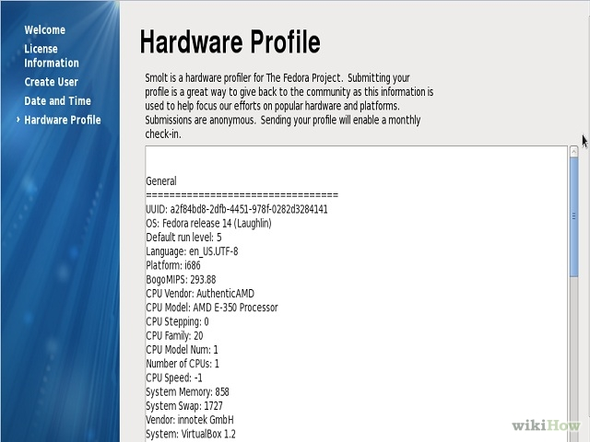](http://www.wikihow.com/Image:Install-Fedora-Step-18.jpg)

**Optional:** Send details about your hardware to the Fedora Project to further help them develop the software according to hardware specifications.

[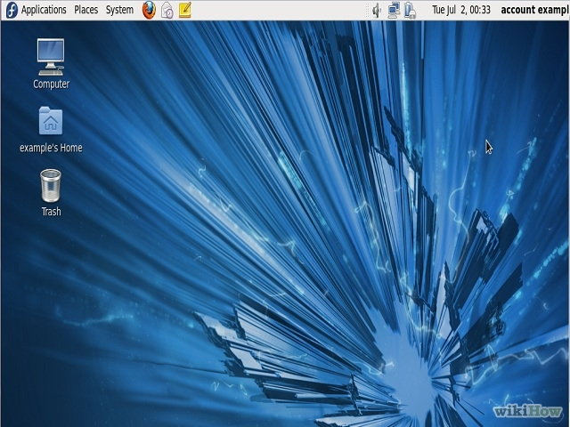](http://www.wikihow.com/Image:Install-Fedora-Step-19.jpg)

**Log-in and enter your password and you can now call yourself a Fedora user.** This is how your Fedora desktop will look.

|  |
| --- |
|  |

### Warnings

* Turning off the computer during the installation can render your system unbootable.
* Most Linux distributions allow you to download and install proprietary drivers. Be aware that this may be illegal in some countries where Intellectual Property rights are enforced (Ex. U.S.A.) be sure to check out the laws in your country before downloading and installing, drivers.
* Try the live drive version first. If this version doesn't work correctly chances are Fedora will not work on your PC. Always select this option first to play and make sure this is an OS you will be happy with.
  + NOTE: The live drive version uses basic 'generic' drivers that are designed to work on anything (ex. generic VGA drivers for video). Even if this version works, after you install it, you may have some issues with drivers that are proprietary. You can still use generic drivers, but you will not have access to some of the special features your hardware may have (e.g, 3-D rendering may not work with a generic driver).
* This installation erases any other operating system you might have on your system so make sure you have backed up all important data

# SERVERS

A server is a system that responds to requests across a computer to provide or help to provide a network service. Can be run on a dedicated computer but as well many networked computers are capable of hosting servers.

They operate within client-server architecture; they are computer programs running to serve requests of other programs i.e. the clients.

Clients connect to the server through the network but may run on the same computer. In the context of Internet Protocol (IP) networking, a server is a program that operates as a socket listener.

Computing servers are;

* Database
* File
* Mail
* Print
* Web
* Named
* Application
* Gaming

In theory, any computerized process that shares a resource to one or more client processes is a server. For instance, while the existence of a file in a machine doesn’t classify it as a server, the mechanism which shares these files to clients by the operating is the server. It is the machine’s role that places it in the category of server.

In the hardware sense, server designates computer models intended for hosting software applications under the heavy demand of a network environment.

While any PC is capable of acting as a network server, a dedicated server will contain features making it more suitable for production environments. These features may include; faster CPU, increased high-performance RAM and increased storage capacity of a larger or multiple hard-drives.

Features of servers;

* Reliability
* Availability
* Serviceability
* Fault tolerance.
* Redundancy in power supplies, storage and network connections

Features of a good server operating system;

* GUI not available or optional
* Ability to reconfigure and update both hardware and software to some extent without restart
* Advanced backup facilities to permit regular and frequent online backups of critical data
* Transparent data transfer between different volumes or devices
* Flexible and advanced networking capabilities
* Automation capabilities
* Tight advanced security with advanced user, resource, data and memory protection.

## How to create servers on a PC

For the start one can try to create the following servers on their PC. First and foremost these instructions work well for those using either fedora 18/19 or centOS 6.

We are going to create the following servers;

* Named (DNS)
* Mali
* FTP(File Transfer Protocol)
* Web
* Database

### Setting up DNS (BIND)

DNS (Domain Name System) provides a naming resolution making it easy for human us human beings to use the internet and other tasks, in other words it helps in interpreting the IP(Internet Protocol) addresses to names that can easily be known.

Below are the steps necessary to configure your own DNS to assist in internal name resolution as well; as provide a caching service for external domains.

This is where you use the static IP. We have both static and dynamic DNS.

**i.) Initial configuration.**

For a Linux host to use DNS, the system resolver must be told which name servers to use,an information that is stored in the /etc/resolv.conf file. As with any configuration, we should always backup the original configuration file before editing it. This is done by typing the following command as the root;

cp /etc/resolv.conf /etc/resolv.conf.original

and then edit using an editor of your choice such as vi or an improved version of vi which is vim or even gedit. In case you choose to use vim then you type;

vim /etc/resolv.conf

You then configure the primary DNS using the following server details;

Operating System : Fedora 18 32 bit

Hostname : **masterdns.faithqueen.co.ke (**choose a domain that you want**)**

IP Address : **192.168.0.170 (**put the ip address of your PC**)**

* Install bind in your system;

[root@masterdns ~]# yum install bind* -y

* The main configuration of the DNS will look like below. Edit and add the entries which are marked as bold in this configuration files.

[root@masterdns ~]# vim /etc/named.conf

//

// named.conf

//

// Provided by Red Hat bind package to configure the ISC BIND named(8) DNS

// server as a caching only nameserver (as a localhost DNS resolver only).

//

// See /usr/share/doc/bind*/sample/ for example named configuration files.

//

options {

listen-on port 53 { **192.168.0.170;**}; **## Master DNS ##**

listen-on-v6 port 53 { ::1; };

directory "/var/named";

dump-file "/var/named/data/cache_dump.db";

        statistics-file "/var/named/data/named_stats.txt";

        memstatistics-file "/var/named/data/named_mem_stats.txt";

allow-query     { localhost; **192.168.0.170;** }; **## Slave DNS IP ##**

recursion yes;

dnssec-enable yes;

dnssec-validation yes;

dnssec-lookaside auto;

/* Path to ISC DLV key */

bindkeys-file "/etc/named.iscdlv.key";

managed-keys-directory "/var/named/dynamic";

};

logging {

        channel default_debug {

                file "data/named.run";

                severity dynamic;

        };

};

zone "." IN {

type hint;

file "named.ca";

};

**zone "faithqueen.co.ke" IN {**

**type master;**

**file "fwd.faithqueen.co.ke";**

**allow-update { none; };**

**};**

**zone "0.168.192.in-addr.arpa" IN {**

**type master;**

**file "rev.faithqueen.co.ke";**

**allow-update { none; };**

**};**

include "/etc/named.rfc1912.zones";

include "/etc/named.root.key";

**ii.) Creating Zone files**

*Create Forward Zone*

Create ‘**fwd.faithqueen.co.ke ’** file in the ‘**/var/named’** directory and add the entries for forward zone as shown below.

[root@masterdns ~]# vi /var/named/fwd.**faithqueen.co.ke**

$TTL 86400

@   IN  SOA     masterdns.**faithqueen.co.ke** root.**faithqueen.co.ke**. (

        20   ;Serial

        3600         ;Refresh

        1800         ;Retry

        604800       ;Expire

        86400       ;Minimum TTL

)

@ IN  NS   masterdns.**faithqueen.co.ke.**

@ IN  NS  slavedns.**faithqueen.co.ke**.

MX 1 mail

masterdns     IN  A     **192.168.0.170**

slavedns IN A **192.168.0.170**

ftp CNAME masterdns

www CNAME masterdns

*Create Reverse Zone*

Create ‘**rev.ostechnix.com’** file in the ‘**/var/named’** directory and add the entries for reverse zone as shown below.

[root@masterdns ~]# vi /var/named/rev.**faithqueen.co.ke.**

$TTL 86400

@   IN  SOA     masterdns.**faithqueen.co.ke.** root.**faithqueen.co.ke.** (

        20  ;Serial

        3600        ;Refresh

        1800        ;Retry

        604800      ;Expire

        86400       ;Minimum TTL

)

@ IN  NS     masterdns.**faithqueen.co.ke.**

@ IN  NS       slavedns.**faithqueen.co.ke.**

masterdns IN  A   **192.168.0.170**

slavedns IN  A   **192.168.0.170**

**170**    IN  PTR     masterdns.**faithqueen.co.ke.**

**170** IN  PTR     slavedns.**faithqueen.co.ke.**

**iii.) Start the bind service**

[root@masterdns ~]# service named start

Then check the configuration of the bind using;

[root@masterdns ~]# chkconfig named on

**iv.) Allow DNS Server through iptables.**

**iptables** are the tables provided by the Linux kernel firewall and the chains and rules it stores. It is used to set up,maintain and inspect the tables of IP packet filter rules in the linux kernel.

Add the lines shown in bold letters in ‘**/etc/sysconfig/iptables’** file. This will allow all clients to access the DNS server.

[root@masterdns ~]# vi /etc/sysconfig/iptables

# Firewall configuration written by system-config-firewall

# Manual customization of this file is not recommended.

*filter

:INPUT ACCEPT [0:0]

:FORWARD ACCEPT [0:0]

:OUTPUT ACCEPT [0:0]

**-A INPUT -p udp -m state --state NEW --dport 53 -j ACCEPT**

**-A INPUT -p tcp -m state --state NEW --dport 53 -j ACCEPT**

-A INPUT -m state --state ESTABLISHED,RELATED -j ACCEPT

-A INPUT -p icmp -j ACCEPT

-A INPUT -i lo -j ACCEPT

-A INPUT -m state --state NEW -m tcp -p tcp --dport 22 -j ACCEPT

-A INPUT -j REJECT --reject-with icmp-host-prohibited

-A FORWARD -j REJECT --reject-with icmp-host-prohibited

COMMIT

**v.) Restart the iptables**

[root@masterdns ~]# service iptables restart

**vi.) Test syntax errors of DNS configuration and zone files**

*Check DNS config file*

root@masterdns ~]# named-checkconf /etc/named.conf

[root@masterdns ~]# named-checkconf /etc/named.rfc1912.zones

*Check zone files*

[root@masterdns ~]# named-checkzone **faithqueen.co.ke** /var/named/fwd.**faithqueen.co.ke**

[root@masterdns ~]# named-checkzone **faithqueen.co.ke** /var/named/rev.**faithqueen.co.ke**

**vii.) Test DNS Server**

dig masterdns.**faithqueen.co.ke**

### Setting up Mail Server.

In order to set up a mail server, you need to install Postfix, Dovecot and SquirrelMail. Before installing postfix, remove sendmail from the server since it is usually the default MTA(Mail Transfer Agent) in fedora/redhat.

Type the following command to remove sendmail,

[root@server ~]# yum remove sendmail

N/B:The mail server should contain a valid MX record in the DNS server.

Firewall and SELinux should be disabled using the following commands;

[root@server ~]# service iptables stop

[root@server ~]# service ip6tables stop

[root@server ~]# chkconfig iptables off

[root@server ~]# chkconfig ip6tables off

And selinux is disabled as below

[root@server ~]# vim /etc/selinux/config

# This file controls the state of SELinux on the system.

# SELINUX= can take one of these three values:

#     enforcing - SELinux security policy is enforced.

#     permissive - SELinux prints warnings instead of enforcing.

#     disabled - No SELinux policy is loaded.

**SELINUX=disabled**

# SELINUXTYPE= can take one of these two values:

#     targeted - Targeted processes are protected,

#     mls - Multi Level Security protection.

SELINUXTYPE=targeted

Hostname = **mail.faithqueen.co.ke**

IP Address = **192.168.0.170**

**Postfix**

Postfix is installed by default and if not, use the below command to install postfix

[root@server ~]# yum install postfix

Then configure postfix as below;

[root@server ~]# vi /etc/postfix/main.cf

myhostname = **mail.faithqueen.co.ke##line no 75 - uncomment and enter your host name**

mydomain = **faithqueen.co.ke** **##line no 83 - uncomment and enter your domain name**

myorigin = $mydomain **##line no 99 - uncomment**

inet_interfaces = all **##line no 116 - change to all**

mydestination = $myhostname, localhost.$mydomain, localhost, $mydomain **##line no 164 - add $domain at the end**

mynetworks = 192.168.0.0/24, 127.0.0.0/8 **##line no 264 - uncomment and add your network range**

home_mailbox = Maildir/ **##line no 419 – uncomment**

Start the postfix service.

[root@server ~]# service postfix start

[root@server ~]# chkconfig postfix on

Test Postfix;

N/B:The commands shown in bold letters should be entered by the user.

The dot after the test command is important.

[root@server ~]# **telnet localhost smtp**

Trying ::1...

Connected to localhost.

Escape character is '^]'.

220 **mail.faithqueen.co.ke** ESMTP Postfix

**ehlo localhost**

250- **mail.faithqueen.co.ke**

250-PIPELINING

250-SIZE 10240000

250-VRFY

250-ETRN

250-ENHANCEDSTATUSCODES

250-8BITMIME

250 DSN

**mail from:<user1>**

250 2.1.0 Ok

rcpt to:<user1>

250 2.1.5 Ok

data

354 End data with <CR><LF>.<CR><LF>

**test**

**.**

250 2.0.0 Ok: queued as 117113FF18

quit

221 2.0.0 Bye

Connection closed by foreign host.

Check Mail

[root@server ~]# **cd /home/user1/Maildir/new/**

[root@server new]# ls

1360236956.Vfd00I35afM181256.server.ostechnix.com

[root@server new]# **cat 1360236956.Vfd00I35afM181256.server.ostechnix.com**

Return-Path: <user1@**faithqueen.co.ke**>

X-Original-To: user1

Delivered-To: user1@o**faithqueen.co.ke**

Received: from localhost (localhost [IPv6:::1])

by server.ostechnix.com (Postfix) with ESMTP id 117113FF18

for <user1>; Thu,  7 Feb 2013 17:05:32 +0530 (IST)

Message-Id: <20130207113547.117113FF18@**mail.faithqueen.co.ke**>

Date: Thu,  7 Feb 2013 17:05:32 +0530 (IST)

From: user1@ostechnix.com

To: undisclosed-recipients:;

**test**

**Dovecot**

Start by installing dovecot using the following command;

[root@server ~]# yum install dovecot

Then configure dovecot

i.) Open the dovecot config file ***/etc/dovecot/dovecot.conf***. Find and uncomment the line as shown below.

[root@server ~]# vim /etc/dovecot/dovecot.conf

protocols = imap pop3 lmtp

ii.) Open the ***/etc/dovecot/conf.d/10-auth.conf*** and edit as shown below.

[root@server ~]# vi /etc/dovecot/conf.d/10-auth.conf

disable_plaintext_auth = no

auth_mechanisms = plain login

iii.)Open the ***/etc/dovecot/conf.d/10-master.conf*** and edit as shown below.

unix_listener auth-userdb {

    #mode = 0600

    user = postfix

group = postfix

Start the dovecot service.

[root@server ~]# service dovecot start

[root@server ~]# chkconfig dovecot on

Create users so that you can send a message to help you confirm the working of your dovecot.

You can create user1 and user2 as follows;

[root@server ~]# useradd user1

[root@server ~]# useradd user2

[root@server ~]# passwd user1

[root@server ~]# passwd user2

Test Dovecot

The commands shown in bold should be entered by the user.

[root@server ~]# **telnet localhost pop3**

Trying ::1...

Connected to localhost.

Escape character is '^]'.

+OK Dovecot ready.

**user user1**

+OK

**pass user1**

+OK Logged in.

**list**

+OK 1 messages:

1 428

.

**retr 1**

+OK 428 octets

Return-Path: <user1@ostechnix.com>

X-Original-To: user1

Delivered-To: user1@ostechnix.com

Received: from localhost (localhost [IPv6:::1])

by server.ostechnix.com (Postfix) with ESMTP id 117113FF18

for <user1>; Thu,  7 Feb 2013 17:05:32 +0530 (IST)

Message-Id: <20130207113547.117113FF18@server.ostechnix.com>

Date: Thu,  7 Feb 2013 17:05:32 +0530 (IST)

From: user1@ostechnix.com

To: undisclosed-recipients:;

**test**

**.**

**quit**

+OK Logging out.

Connection closed by foreign host.

[root@server ~]#

**Squirrelmail**

This is a MTA just like sendmail.

To install squirrelmail, you first need to install EPEL repository and then install SquirrelMail package from EPEL repository.

To install EPEL repository, use the following command;

[root@server ~]# wget <http://dl.fedoraproject.org/pub/epel/6/i386/epel-release-6-8.noarch.rpm>

[root@server ~]# rpm -ivh epel-release-6-8.noarch.rpm

Then yum install squirrelmail;

[root@server ~]# yum install squirrelmail

[root@server ~]# chkconfig httpd on

Configure Squirrelmail

Go to the squirrelmail config directory and use the command **./conf.pl** to start configure as below,

[root@server ~]# cd /usr/share/squirrelmail/config/

[root@server config]# **./conf.pl**

[root@server ~]# service httpd restart

### Setting up the file

Here I set up the FTP server.

First stop the firewall as follows;

[root@mainserver ~]# service iptables stop

[root@mainserver ~]# service ip6tables stop

[root@mainserver ~]# chkconfig iptables off

[root@mainserver ~]# chkconfig ip6tables off

You can now install FTP server, why do we stop firewall? This is because firewall restricts users from accessing your server and in order to be able to share files with them.

Type the following command

[root@mainserver ~]# yum install -y vsftpd

[root@mainserver ~]# Start vsftpd service.

[root@mainserver ~]# service vsftpd start

Then enable vsftpd in multi-user levels

[root@mainserver ~]# chkconfig vsftpd on

Edit the ***/etc/vsftpd/vsftpd.conf*** file by uncommenting the lines shown in bold

[root@mainserver ~]#vim /etc/vsftpd/vsftpd.conf

# Example config file /etc/vsftpd/vsftpd.conf

#

# The default compiled in settings are fairly paranoid. This sample file

# loosens things up a bit, to make the ftp daemon more usable.

# Please see vsftpd.conf.5 for all compiled in defaults.

#

# READ THIS: This example file is NOT an exhaustive list of vsftpd options.

# Please read the vsftpd.conf.5 manual page to get a full idea of vsftpd's

# capabilities.

#

# Allow anonymous FTP? (Beware - allowed by default if you comment this out).

**anonymous_enable=NO**

#

# Uncomment this to allow local users to log in.

local_enable=YES

#

# Uncomment this to enable any form of FTP write command.

write_enable=YES

#

# Default umask for local users is 077. You may wish to change this to 022,

# if your users expect that (022 is used by most other ftpd's)

local_umask=022

#

# Uncomment this to allow the anonymous FTP user to upload files. This only

# has an effect if the above global write enable is activated. Also, you will

# obviously need to create a directory writable by the FTP user.

#anon_upload_enable=YES

#

# Uncomment this if you want the anonymous FTP user to be able to create

# new directories.

#anon_mkdir_write_enable=YES

#

# Activate directory messages - messages given to remote users when they

# go into a certain directory.

dirmessage_enable=YES

#

# The target log file can be vsftpd_log_file or xferlog_file.

# This depends on setting xferlog_std_format parameter

xferlog_enable=YES

#

# Make sure PORT transfer connections originate from port 20 (ftp-data).

connect_from_port_20=YES

#

# If you want, you can arrange for uploaded anonymous files to be owned by

# a different user. Note! Using "root" for uploaded files is not

# recommended!

#chown_uploads=YES

#chown_username=whoever

#

# The name of log file when xferlog_enable=YES and xferlog_std_format=YES

# WARNING - changing this filename affects /etc/logrotate.d/vsftpd.log

#xferlog_file=/var/log/xferlog

#

# Switches between logging into vsftpd_log_file and xferlog_file files.

# NO writes to vsftpd_log_file, YES to xferlog_file

xferlog_std_format=YES

#

# You may change the default value for timing out an idle session.

#idle_session_timeout=600

#

# You may change the default value for timing out a data connection.

#data_connection_timeout=120

#

# It is recommended that you define on your system a unique user which the

# ftp server can use as a totally isolated and unprivileged user.

#nopriv_user=ftpsecure

#

# Enable this and the server will recognise asynchronous ABOR requests. Not

# recommended for security (the code is non-trivial). Not enabling it,

# however, may confuse older FTP clients.

#async_abor_enable=YES

#

# By default the server will pretend to allow ASCII mode but in fact ignore

# the request. Turn on the below options to have the server actually do ASCII

# mangling on files when in ASCII mode.

# Beware that on some FTP servers, ASCII support allows a denial of service

# attack (DoS) via the command "SIZE /big/file" in ASCII mode. vsftpd

# predicted this attack and has always been safe, reporting the size of the

# raw file.

# ASCII mangling is a horrible feature of the protocol.

**ascii_upload_enable=YES**

**ascii_download_enable=YES**

#

# You may fully customise the login banner string:

**ftpd_banner=Welcome to ACQUEENO FTP service.**

#

# You may specify a file of disallowed anonymous e-mail addresses. Apparently

# useful for combatting certain DoS attacks.

#deny_email_enable=YES

# (default follows)

#banned_email_file=/etc/vsftpd/banned_emails

#

# You may specify an explicit list of local users to chroot() to their home

# directory. If chroot_local_user is YES, then this list becomes a list of

# users to NOT chroot().

#chroot_local_user=YES

#chroot_list_enable=YES

# (default follows)

#chroot_list_file=/etc/vsftpd/chroot_list

#

# You may activate the "-R" option to the builtin ls. This is disabled by

# default to avoid remote users being able to cause excessive I/O on large

# sites. However, some broken FTP clients such as "ncftp" and "mirror" assume

# the presence of the "-R" option, so there is a strong case for enabling it.

ls_recurse_enable=YES

#

# When "listen" directive is enabled, vsftpd runs in standalone mode and

# listens on IPv4 sockets. This directive cannot be used in conjunction

# with the listen_ipv6 directive.

listen=YES

#

# This directive enables listening on IPv6 sockets. To listen on IPv4 and IPv6

# sockets, you must run two copies of vsftpd with two configuration files.

# Make sure, that one of the listen options is commented !!

#listen_ipv6=YES

pam_service_name=vsftpd

userlist_enable=YES

tcp_wrappers=YES

**use_localtime=YES**

Restart the vsftpd service and try to connect to ftp server as

[root@mainserver ~]# service vsftpd restart

Connect to the ftp server.

N/B:**Root is not allowed to connect to ftp server by default for security purpose, so you can create a new user such as queen.**

But before connecting you have to install ftp package.

[root@mainserver ~]# yum install -y ftp

Connet to FTP server using the new user ***queen***.

[root@mainserver ~]# ftp 192.168.0.170

### Setting up a Apache Web server

The OS is Fedora 18

Hostname is web.faithqueen.co.ke

IP address is 192.168.0.170

* + 1. **Set the hostname of web server**

[root@web ~]# vim /etc/sysconfig/network

NETWORKING=yes

HOSTNAME=web.ostechnix.com

* + 1. **Add the webserver hostname in ‘*etc/hosts’* file**

[root@web ~]# vim /etc/hosts

127.0.0.1   localhost localhost.localdomain localhost4 localhost4.localdomain4

::1         localhost localhost.localdomain localhost6 localhost6.localdomain6

192.168.1.250   web.faithqueen.com

192.168.1.250   web.faithqueen.com

**Install Apache**

Check and remove any previously installed packages

[root@web ~]# rpm -qa | grep httpd

or

[root@web ~]# yum list installed | grep httpd

Now install the ‘**httpd’** package

[root@web ~]# yum install httpd* -y

* + 1. **Configure Apache**

[root@web ~]# vim /etc/httpd/conf/httpd.conf

ServerAdmin root@faithqueen.com

ServerName [www.faithqueen.com:80](http://www.faithqueen.com:80)

DocumentRoot "/var/www/html"

DirectoryIndex faithqueen.html

* + 1. **Create a sample index or home page**

Create the index or home page html file in the ‘**/var/www/html/’** directory

[root@web ~]# vim /var/www/html/faithqueen.html

create a web page.

* + 1. **Allow webserver through firewall**

[root@web ~]# vim /etc/sysconfig/iptables

# Firewall configuration written by system-config-firewall

# Manual customization of this file is not recommended.

*filter

:INPUT ACCEPT [0:0]

:FORWARD ACCEPT [0:0]

:OUTPUT ACCEPT [0:0]

-A INPUT -m state --state ESTABLISHED,RELATED -j ACCEPT

-A INPUT -p icmp -j ACCEPT

-A INPUT -i lo -j ACCEPT

**-A INPUT -p tcp -m state --state NEW --dport 80 -j ACCEPT**

**-A INPUT -p tcp -m state --state NEW --dport 80 -j ACCEPT**

-A INPUT -m state --state NEW -m tcp -p tcp --dport 22 -j ACCEPT

-A INPUT -j REJECT --reject-with icmp-host-prohibited

-A FORWARD -j REJECT --reject-with icmp-host-prohibited

COMMIT

Restart iptables to save changes

[root@web ~]# service iptables restart

* + 1. **Start Apache web server**

[root@web ~]# service httpd start

[root@web ~]# chkconfig httpd on

### Setting up database server (Postgresql)

I used the version 9.2 of the postgresql in centos and the following are the steps that I followed:

* 1. **Download and install the postgresql repository**

In this case type the following at the command line so to install the repository for postgresql 9.2;

*wget* [*http://yum.pgrpms.org/9.2/redhat/rhel-6-x86_64/pgdg-centos91-9.2-4.noarch.rpm*](http://yum.pgrpms.org/9.1/redhat/rhel-6-x86_64/pgdg-centos91-9.1-4.noarch.rpm)

Then type the following in the command line to install the package pgdg-centos91-9.2-4.noarch;

*rpm -ivh pgdg-centos91-9.2-4.noarch.rpm*

Edit the CentOS-Base.repo to exclude postgreql. To do so, simply edit CentOS-Base.repo and add 'exclude=postgresql*' to the [base] and [updates] sections:

You need as well to change the directory to yum.repos.d

**[**[**root@server1**](mailto:root@server1) **~]# cd /etc/yum.repos.d**

**[**[**root@server1**](mailto:root@server1) **yum.repos.d]# vim CentOS-Base.repo**

# remarked out baseurl= line instead.

#

#

[base]

name=CentOS-$releasever - Base

mirrorlist=http://mirrorlist.centos.org/?release=$releasever&arch=$basearch&repo=os

#baseurl=http://mirror.centos.org/centos/$releasever/os/$basearch/

gpgcheck=1

gpgkey=file:///etc/pki/rpm-gpg/RPM-GPG-KEY-CentOS-6

exclude=postgresql*

#released updates

[updates]

name=CentOS-$releasever - Updates

mirrorlist=http://mirrorlist.centos.org/?release=$releasever&arch=$basearch&repo=updates

#baseurl=http://mirror.centos.org/centos/$releasever/updates/$basearch/

gpgcheck=1

gpgkey=file:///etc/pki/rpm-gpg/RPM-GPG-KEY-CentOS-6

exclude=postgresql*

Now, let's use 'yum list' to check the packages that are now available.

**[**[**root@server1**](mailto:root@server1) **yum.repos.d]# yum list postgres\***

'*' used so that it lists all the postgres files in the system

* 1. **Install PostgreSQL 9.2 Using Yum**

Now install PostgreSQL 9.2 using yum:

*yum install postgresql92 postgresql92-devel postgresql92-server postgresql92-libs postgresql92-contrib*

**[**[**root@server1**](mailto:root@server1)**yum.repos.d]# yum install postgresql92 postgresql92-devel postgresql92-**

* 1. **Initialize and Start PostgreSQL 9.2**

Initialize and then Start PostgreSQL

**[**[**root@server1**](mailto:root@server1) **yum.repos.d]# service postgresql-9.2 initdb**

initializing database:                                     [  OK  ]

Start the PostgreSQL server:

**[**[**root@server1**](mailto:root@server1) **yum.repos.d]# service postgresql-9.2 start**

starting postgresql-9.2 service:                           [  OK  ]

**[**[**root@server1**](mailto:root@server1) **yum.repos.d]#**

If you encounter startup errors, check under /var/lib/pgsql/9.2/data/pg_log for clues.   
**iv) Set postgres Password**

The superuser postgres has no password set by default.

To set the password, switch to postgres user:

**[**[**root@server1**](mailto:root@server1) **yum.repos.d]# su - postgres**

Connect as postgres to the postgres database and set the password for user postgres using alter user as below:

-bash-4.1$ psql postgres postgres

psql (9.1.1)

Type "help" for help.

postgres=# alter user postgres with password 'postgres';

ALTER ROLE

postgres=#

* 1. **Configure PostgreSQL 9 pg_hba.conf File**

Locate your pg_hba.conf file under /var/lib/pgsql/9.2/data. On installation, your pg_hba.conf file will look like this:

**[**[**root@server1**](mailto:root@server1)**yum.repos.d]# vim /var/lib/pgsql/9.2/data/pg_hba.conf**

# Put your actual configuration here

# ----------------------------------

#

# If you want to allow non-local connections, you need to add more

# "host" records.  In that case you will also need to make PostgreSQL

# listen on a non-local interface via the listen_addresses

# configuration parameter, or via the -i or -h command line switches.

# TYPE  DATABASE        USER            ADDRESS                 METHOD

# "local" is for Unix domain socket connections only

local    all              all                                      peer

# IPv4 local connections:

host      all              all             127.0.0.1/32             ident

# IPv6 local connections:

host     all              all             ::1/128                  ident

# Allow replication connections from localhost, by a user with the

# replication privilege.

#local   replication     postgres                                peer

#host    replication     postgres        127.0.0.1/32            ident

#host    replication     postgres        ::1/128                 ident    
**Change the METHOD to md5 as shown below**:

# TYPE  DATABASE        USER            ADDRESS                 METHOD

# "local" is for Unix domain socket connections only

local    all              all                                      md5

* # IPv4 local connections:

host     all              all             127.0.0.1/32             md5

# IPv6 local connections:

host     all              all             ::1/128                  md5

In order for the change to take effect, reload the pg_hba.conf file. This can be done in any of these three ways:

Method 1: From the shell using pg_ctl reload:

**[**[**root@server1**](mailto:root@server1) **yum.repos.d]# su - postgres**

-bash-4.1$ pg_ctl reload

server signaled

-bash-4.1$

Method 2: From psql using pg_reload_conf();

-bash-4.1$ psql postgres postgres

psql (9.1.1)

Type "help" for help.

postgres=# select pg_reload_conf();

 pg_reload_conf

----------------

 t

(1 row)

postgres=#

Method 3: From the shell using -c switch to run select pg_reload_conf();

-bash-4.1$ psql postgres postgres -c "select pg_reload_conf();"

Password for user postgres:

 pg_reload_conf

----------------

 t

(1 row)

-bash-4.1$    
 vi.)  **Configure Remote Access for PostgreSQL 9**  
Locate the postgresql.conf file under /var/lib/pgsql/9.2/data.  
Look for CONNECTIONS AND AUTHENTICATION. It will look as below:

**[**[**root@server1**](mailto:root@server1) **yum repos.d]# vim /var/lib/pgsql/9.2/data/postgresql.conf**

#------------------------------------------------------------------------------

# CONNECTIONS AND AUTHENTICATION

#------------------------------------------------------------------------------

# - Connection Settings -

#listen_addresses = 'localhost'     # what IP address(es) to listen on;

                    # comma-separated list of addresses;

                    # defaults to 'localhost', '*' = all

                    # (change requires restart)

#port = 5432                # (change requires restart)    
By default, access is limited to local machine i.e. localhost.  
To enable remote connections, uncomment listen_addresses and change to '*' as shown below.

#------------------------------------------------------------------------------

# CONNECTIONS AND AUTHENTICATION

#------------------------------------------------------------------------------

# - Connection Settings

listen_addresses = '*'      # what IP address(es) to listen on;

                    # comma-separated list of addresses;

                    # defaults to 'localhost', '*' = all

                    # (change requires restart)

#port = 5432                # (change requires restart)    
You can also set the listen_address limit to a specific IP (or IPs using a comma separated list).  
Note: For security, it is also a good idea to change the default port. To do this, uncomment port and set to a new port value. If you change the port, you will need to restart the service.

Restart the postgresql service:

**[**[**root@server1**](mailto:root@server1) **yum.repos.d]#service postgresql-9.2 restart**

Stopping postgresql-9.2 service: **[  OK  ]**

Starting postgresql-9.2 service:                           [  OK  ]

**[**[**root@serve1**](mailto:root@serve1) **yum.repos.d]#**

If you encounter startup errors, check under /var/lib/pgsql/9.2/data/pg_log for clues.  
Verify the changes to listen_address and port (if changed):

-bash-4.1$ psql

Password:

psql (9.2.)

Type "help" for help.

postgres=# show listen_addresses;

 listen_addresses

------------------

 *

(1 row)

postgres=# show port;

 port

------

 5432

(1 row)

  postgres=#

* 1. **Create User and Database for PostgreSQL 9**

To check Check functionality, connect to postgres db as user postgres.

**[**[**root@server1**](mailto:root@server1) **yum.repos.d]# psql postgres postgres**

Password for user postgres:

psql (9.1.1)

Type "help" for help.

postgres=#

Create a user:

postgres=# create user Faith with password 'faith';

CREATE ROLE    
Create a database and give ownership to the new user:

postgres=# create database myfirstdb owner=Faith;

CREATE DATABASE    
Connect to the database as user:

postgres=# \c mytestdb myuser

Password for user myuser:

You are now connected to database "myfirstdb" as user "Faith".    
Create a table and insert row(s):

mytestdb=> create table testtable (col1 varchar);

CREATE TABLE

mytestdb=> insert into testtable values('hello');

INSERT 0 1    
Select on the table you created:

mytestdb=> select * from testtable;

 col1

-------

 hello

(1 row)

mytestdb=>

Describe table:

mytestdb=> \dt

          List of relations

 Schema |   Name    | Type  | Owner

--------+-----------+-------+--------

 public | testtable | table | myuser

* (1 row)    
  Note: By default the schema used is Public. You should create a specific schema for your users.
  1. **Yum Install pgAdmin III:**

This is a PostgreSQL data base management program.

**[**[**root@server1**](mailto:root@server1) **yum.repos.d]# yum install pgadmin**

It is from this that now you type all your SQL statements and execute them.